BAYSIDE REGIONAL TENNIS ASSOCIATION INC
Reg #A0040463W

Proudly Supported By:
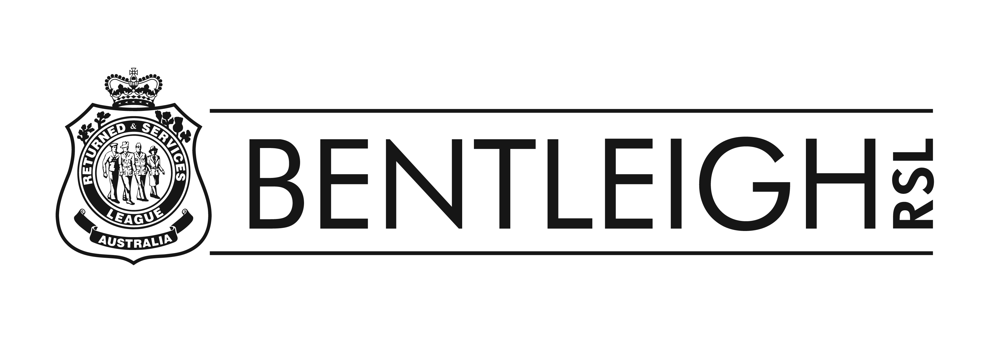
Club Remittance Advice Form – Saturday & Sunday Junior Competition
Season February - June 2021
This form must accompany your team entry forms and be forwarded to Mrs Jillian Sanders: 1 Sharrock Ave, Cheltenham 3192 or email jillian.sanders@bigpond.com. This form and each entry form, must be signed by your club Secretary or President
Season commences Saturday 30th & Sunday 31st January 2021
ENTRIES CLOSE FRIDAY 4TH DECEMBER 2020
Club Name:……………………………………………………………………………………………………………………………….
Address:……………………………………………………………………………………Tel:………………………………………..
No. of Courts available for these entries (Inc finals):…………………………………………………………………
Court Surface:…………………………………………………………………………………………………………………………..
Secretary:…………………………………………………………………………………………………………………………………
Tel:.......................................Mobile:....................................Email:............................................
Junior Representative:…………………………………………………………………………….
Tel:.........................................Mobile:......................................Email:.............................................

…………………………………………..
REMITTANCE ADVICE

CLUB………………………………………………………………………………………………..Cheque attached for………………………………………………….Saturday Teams @ $50.00
Cheque attached for………………………………………………….Sunday Teams @ $50.00
TOTAL: $............

EFT: BSB 083290 A/C No: 557647485 Payment must have a club name & description of payment for identification purposes

……………………………………………………………………………………………………….
Signature of Club Secretary or President

