BAYSIDE REGIONAL TENNIS ASSOCIATION INC
Reg #A0040463w
Proudly supported by:

MIDWEEK LADIES TUESDAY/WEDNESDAY FINALS VENUES FEB – JUNE 2019
WEDNESDAY | SEMI/FINAL | SEMI/FINAL | VENUE | GRAND/FINAL
SECTION |  |  |  | 05/06/2019
1 |  |  | PARKDALE | 1 V 2
2 |  |  | STELLA MARIS | 1 V 2
3 |  |  | BLACK ROCK | 1 V 2
4 |  |  | BEAUMARIS C C | 1 V 2
TUESDAY |  | 28/05/2019 | 28/05/2019 | 04/06/2019
SECTION |  | SEMI/FINAL | SEMI /FINAL | GRAND /FINAL
 |  | 1 V 4 | 2 V 3
1 |  | DINGLEY | DINGLEY | DINGLEY

Venue clubs please have courts open 15 minutes prior to start of matches
Venue club to supply coffee, tea, milk and sugar
Both teams to provide 1 pair of new balls
Good luck to all finalists

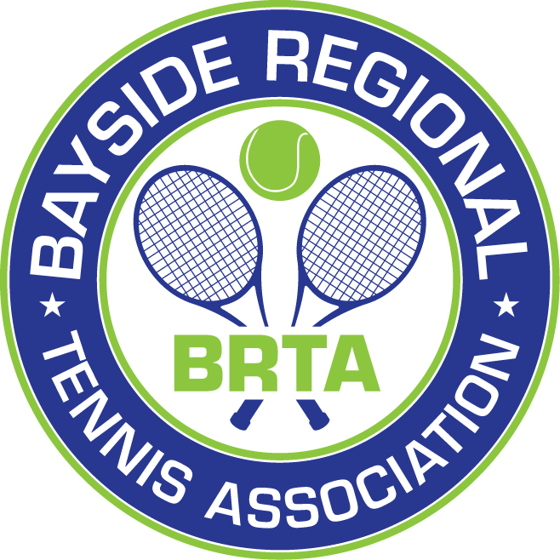

Kerry Wundersitz
Secretary, BRTA Inc

